PART 1

5. Can you please give me the correct answer for these questions. For some reason I can’t think of how to do it, not sure if I’m over thinking it or what.

I was planning on using a cursor to go through the first problem, but I feel like it’s too overkill for the questions.

6.

7.

8.

9.

PART 2

1.

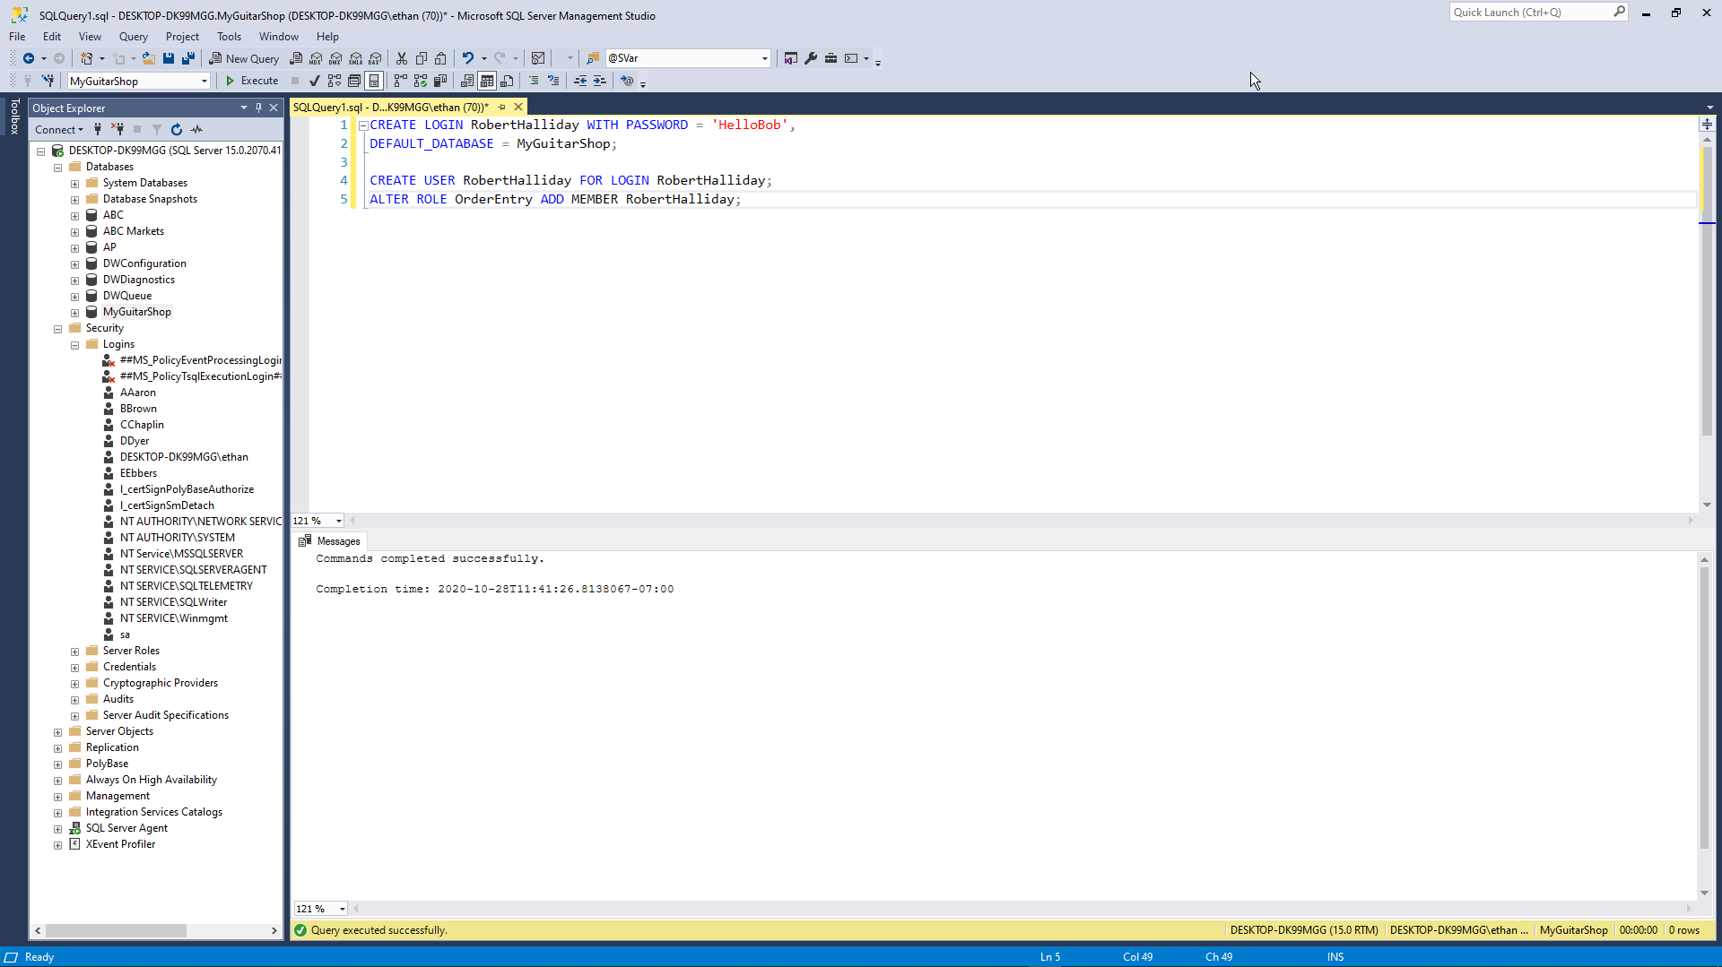

2.



3.

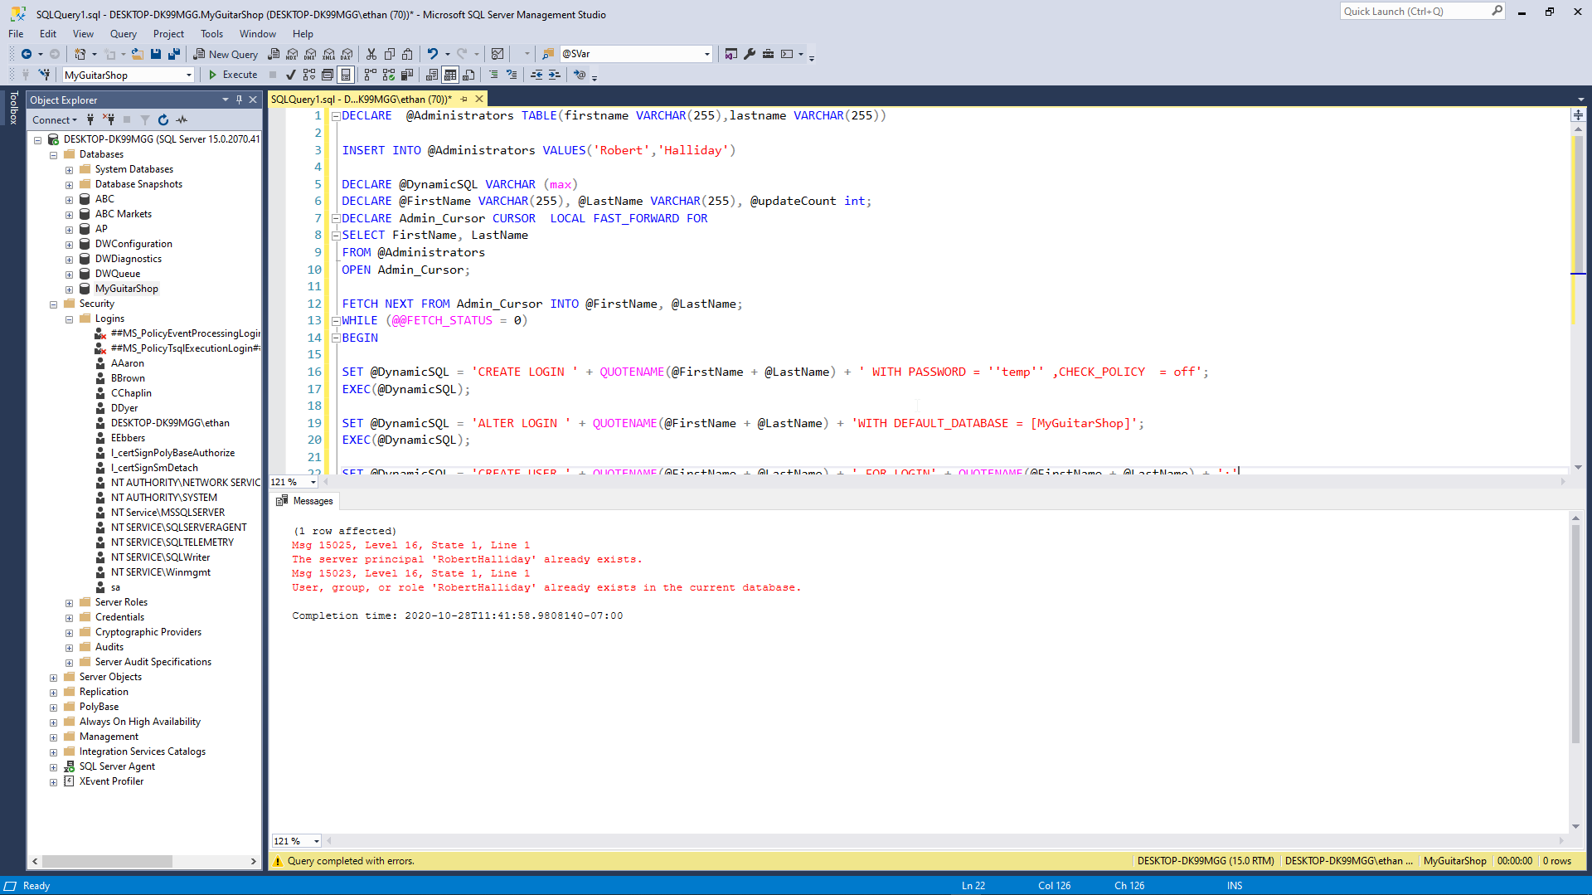

4.

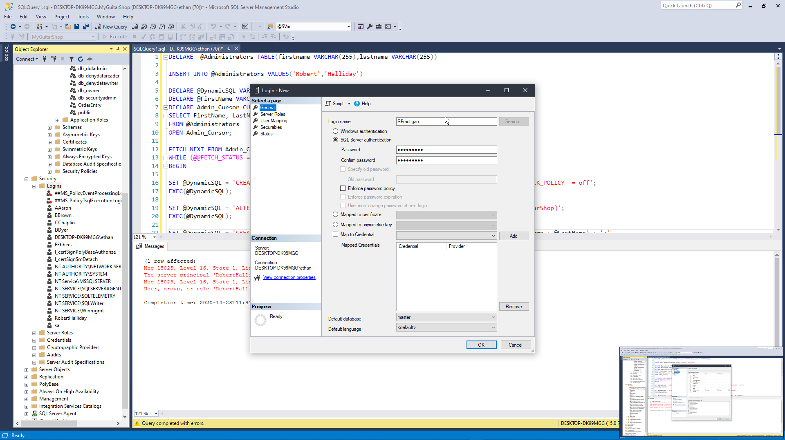

5. (Need help I don’t know how to do a mass drop of all members in the role)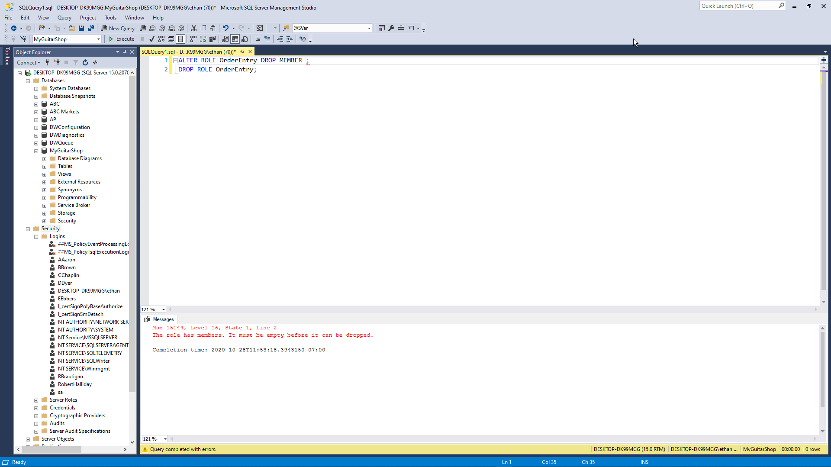

6. 